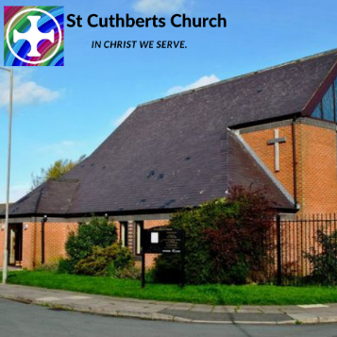

Environmental Policy for St Cuthberts Church in Liverpool Diocese-
1
This policy ntended to be a starting point for helping to shape our thinking for the next 5 years. And we intend to look at our Carbon offset in 2020 and reduce our carbon use in the following 5 years and beyond. We aim to include Enviormental issues and to aim for the Gold Award by Roche Eco Church.
We affirm these elements of our faith:
Through Christ, God has created an awesome and majestic cosmos to bring Him praise and glory. We are but one part of His created order.
Jesus has redeemed the whole earth through His death and resurrection.
We recognise that we have a special responsibility to care for the Earth so that human life and all God’s creatures may be sustained in harmony.
Aim
As a local church, we aim to take the practical steps necessary to realise the Fifth Mark of Mission, which is “to strive to safeguard the integrity of creation and to sustain the life of the earth”.
Objective
As a church community, we will take environmental concerns into account in our mission, worship, study, training, pastoral, administrative and other projects and programmes.
Actions
1. We will appoint Rachel and Laura as our Environmental Officer and Champions to lead our programme and encourage them to bring relevant environmental issues and concerns forward to the PCC on a regular basis.
2. We will include our concern for sustainability in our worship and teaching.
3. We will undertake an environmental and energy audit of the church premises and property, identify the most significant issues and impacts which should be addressed and make and implement plans and programmes to tackle them, recognising that some additional costs may be incurred to minimise environmental impacts.
4. We will work with others in our local community such as the Councillors and the community payback team to identify environmental issues which should be addressed in our area and help develop actions to tackle them. We will arrange a litter pick once a year and encourage people to pick up rubbish when they walk in our area.
5. As the church’s energy use is arguably its greatest environmental issue, we will seek to reduce the greenhouse gas emissions of the electricity and gas used in church premises by: 0.9 tco2 by 2022 Switching to “green” energy suppliers (renewably generated electricity and biogin 2020) )
2
- Using thermostats for temperature control
- Fitting LED light bulbs in main church
- Improving insulation wherever practicable
- Turning off lights, appliances and computers when not in use
- maintain boiler which is a A Grade boiler
6. We will encourage congregation wherever possible to use forms of transport to work, meetings etc. which have minimum or reduced environmental impact – e.g. walk, public transport, car sharing electric/ hydrogen vehicles and cycling. We will complete Travel survey in 2022 once pandemic restrictions are lifted
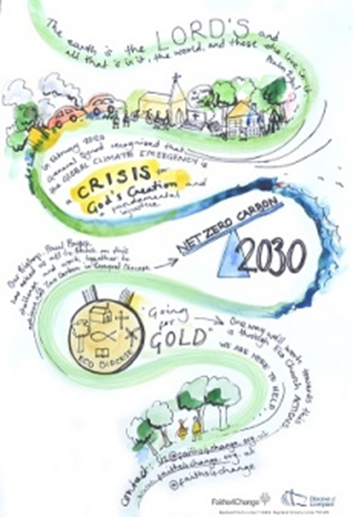
7. We will seek ways to reduce material consumption and the impact of our activities on the environment by, wherever possible:
- serving locally produced food where possible
- minimising the amount of red meat and dairy products served
- using email rather than sending hard copies
- using recycled paper
- reusing/ repairing items
- using low environmental impact cleaning materials
8. We will avoid using water unnecessarily, check for leakages, fit water minimising systems to taps and cisterns wherever practicable. Hippos have been added to toilet cystern to mimise water used per flush. Water butt is to put into use.
9. We will assess our land and property for wildlife and manage them to conserve biodiversity.
10. We will encourage individual members of our congregations to take actions in their personal lives to complement and supplement these actions of the church community.
11. We will participate in the Eco Church programme.
This policy and programme will be reviewed every three years considering developments. Next review date – April 2021.
Useful Resources - Eco Church, A Rocha https://ecochurch.arocha.org.uk/
Shrinking the Footprint, Church Care
Churches Together in Britain and Ireland environment webpage
https://ctbi.org.uk/environment-links#ecochurch
Pray and Fast for the Climatewww.prayandfastfortheclimate.org.uk/
Green Christianwww.greenchristian.org.uk/ Climate Stewardswww.climatestewards.org/
3
Operation Noah http://operationnoah.org/
Caring for God’s Acre, churchyard carewww.caringforgodsacre.org.uk/

